

PSL Recognizer: Empowering Communication through AI

Supervised By
Dr Anam Qureshi

Team Members

Agha Fardeen 21K-3371
Virkha Kumari 21K-4507
Tania Saleh 21K-4695

FAST SCHOOL OF COMPUTING
NATIONAL UNIVERSITY OF COMPUTING AND EMERGING SCIENCES
KARACHI CAMPUS
Session: 2021-2025

Table Of contents:

ABSTRACT 3
1. INTRODUCTION 4
2. LITERATURE REVIEW 5
3. METHODOLOGY 8
3.1 Data Collection 9
3.2 Data Augmentation and Preparation 10
3.3 Training, Evaluation, and Test Split 11
3.4 Training of Deep Learning Models 11
3.4.1 Video Vision Transformer (ViViT) Model 11
3.4.2 ResNet-18 and LSTM network 12
3.4.3 3DCNN + Residual Block + BiLSTM 13
4. RESULTS 14
4.1 Evaluation Metrics 14
4.2 Results Analysis 15
5. CONCLUSION 16
REFERENCES 17

ABSTRACT
The deaf community faces serious challenges due to communication barriers with the general population, leaving their ideas and opinions unexpressed. Significant work has been done on sign language recognition systems for various languages such as American Sign Language (ASL), Argentine Sign Language (LSA64). However, limited work has been conducted for PSL recognition systems, further increasing the communication challenges for deaf society in Pakistan. Furthermore, the limited dataset in terms of examples per sign/label has made it difficult to train deep learning-based PSL recognition systems.
To address this gap, we have devised a pipeline in which we assemble and extend a PSL dataset of 104 PSL daily-use signs. As we collaborated with the PSL organization, we received one official video sample for each sign, and then three team members each recorded three additional video samples, yielding ten original videos per PSL sign. To further enrich the dataset, we applied eleven different randomized image-augmentation operations frame-by-frame such as rotation, scaling, brightness, and Gaussian noise, etc. This step helped to expand the PSL dataset to 60 video clips per sign. All clips were normalized to pixel values in [0,1] before splitting per label into training (80%), validation (15%), and test (5%) sets.
We evaluated three architectures: (1) a tubelet embedding-based Video Vision Transformer (ViViT/32), (2) ResNet-18 backbone with LSTM, and (3) our proposed hybrid “3DCNN + Residual Block + BiLSTM” model. All models were trained using CrossEntropyLoss. While ViViT achieved around 96% accuracy on the training set, this model was affected by overfitting as the accuracy difference between training and evaluation set is around 21%. The ResNet-18 with LSTM network reduced this gap, but still underperformed on held-out data.
Our proposed 3DCNN + Residual Block + BiLSTM architecture, consisting of stacked 3D convolutions, residual learning, and a two-layer bidirectional LSTM, demonstrated better generalization. The performance metrics used were accuracy, precision, recall, and F1 score. This network achieved around 83.89% accuracy on unseen data with loss of 0.59, precision of 0.88, and recall of 0.84, and F1 score of 0.84. These results confirmed the effectiveness of combining spatiotemporal feature extraction with residual learning and sequence modeling.
This study presents the comprehensive advanced deep learning-based PSL recognition system trained on a diversified PSL dataset. Our research and results will help overcome the gap and establish more inclusive communication tools for the Pakistani deaf community.

1. INTRODUCTION
Communication is essential to human interaction. It is a primary medium for the transfer of thoughts, ideas, emotions and building relationships. However, people with hearing or speech impairment face significant challenges, as they rely on sign language for their daily communication, but unfortunately a large number of the general population does not understand sign language which creates a communication barrier between the deaf community and the rest of the society. This barrier further excludes individuals with hearing impairments from accessing education, employment and health care among other basic services.
According to the World Health Organization (W.H.O), over 5% of the world's population suffers from some form of hearing disability [2]. In Pakistan, approximately 10 million individuals are classified as part of the deaf community [3]. Many advancements around the world have been achieved to minimize the communication gap using automatic recognition systems utilizing deep learning and computer vision techniques on sign languages like American Sign Language (ASL), British Sign Language (BSL), and Chinese Sign Language (CSL). However, in the context of Pakistan, where Urdu is the primary spoken language, the deaf community communicates using Pakistan Sign Language (PSL), very limited work and research has been done. The PSL specific solutions are insufficient primarily due to the limited availability of the labeled data set, restricting the training and performance of deep learning models. Additionally many existing solutions fail to provide seamless translation in real time, making them impractical for daily usage. Scalability is another concern as the current solutions are not powerful enough to handle variations in fluency, gestures, and environmental conditions.
Our project aims to address these issues by developing a real time recognition system for PSL using deep learning and multimodal video classification techniques. To this end, we cooperated with the PSL organization and built our own PSL dataset of 104 daily-use signs (extensively data augmented). Several deep learning architectures for gesture classification were trained and assessed, including a ViViT, ResNet-18 + LSTM, and our proposed hybrid 3DCNN + Residual Block + BiLSTM model. The suggested model showed excellent generalization with unseen data, indicating its additional usage as a practical and an inclusive communication tool for deaf people in Pakistan.

2. LITERATURE REVIEW
Communication barriers faced by the individuals with hearing or speech impairments lead them to be unable to participate in the society. Therefore, to assist deaf community, “Sign language” with more than 138 identified forms in the global market such as BSL, ASL, ISL, CSL and PSL were introduced and to overcome the communication barrier. However, the problem persists as many of the individuals remain unaware or lack understanding on “how to communicate using Sign language”. Real-time translation systems through gesture recognition technologies have been developed especially in the developed world and have helped in minimizing this gap [5].
Nonetheless, in the case of Pakistan, research work that is systematic and specifically targeted at the grammar and syntax of PSL, is rather limited [4]. Few of the technological tools have been developed for the purpose of overcoming the communication barriers between the non-deaf and the deaf individuals including gesture recognition systems. On the other hand, in the global context, Kinect Leap Motion devices and sensor-based approaches are effectively used for gesture recognition which has led to improved communication methods.
Due to the recent enhancements in artificial intelligence, the communication through Sign Language has been enhanced especially with the help of CNNs and RNNs models. For example, in the work of Garcia and Viesca [6], they utilized the GoogleNet model pre-trained for the recognition of the American Sign Language (ASL) producing a good accuracy in real time communication setup. In the same manner, Pigou et al [7] proved the usefulness of deep learning in enhancing the efficiency of gesture/sign language recognition systems. In Pakistan, few initial concepts have been suggested for the PSL recognition, however, there is a long way to go to introduce these systems for daily-use purposes. Khan et al [5] proposed models which help to convert PSL videos into text and speech using devices such as Leap Motion and artificial neural networks. However, there is no solution for the scalable and real-time translation solutions as per now.
A research conducted in 2021 [8] in which the system depicted in the image is divided into two main phases namely the generation of the dataset and the recognition of the Urdu Sign Language (USL). First, a Webcam is used to record the images of hand gestures and the hand gestures are classified into thirty seven classes where each of the classes corresponds to a letter of the USL alphabet. The given images are then classified using a Support Vector Machine (SVM). The data set consists of 1480 images, which is divided into training and test dataset respectively, used for model training and testing purposes. This methodology helps to distinguish signs and contribute to the creation of an Android application for sign language translation in real time environment setup.
Recent Research by Hamza and Wali [1] proposed a real time system translation system that addresses the challenge of limited PSL dataset, which typically comprise only two data instances per word. Their system incorporates a data augmentation unit, which synthetically generates new training samples while leaving the testing set unchanged. Their study demonstrated that good results could be achieved even with a limited dataset, proving the effectiveness of augmentation techniques in enhancing the performance of sign language recognition systems.
Recently, in 2024, a gesture recognition system for PSL was proposed [10], which acquires data from Kinect and consists of several steps including data preprocessing, feature extraction and classification. First the captured images are subjected to histogram equalization and resizing to ensure that all images are equally clear regardless of their original size. After that the system categorizes the images into the gesture classes and performs SIFT (Scale-Invariant Feature Transform) on the images for keypoint localisation, where features such as hand margin, size, and finger position are considered. Segmentation through thresholding then followed by feature extraction in order to improve the recognition of the gesture, has been used. In the last, the Convolutional Neural Network (CNN) model is used to classify the gestures to recognize PSL signs.

While Pakistan is making gradual progress, international research continues to push the boundaries of sign language recognition using more advanced and optimized architectures. For example, Smirnova and Kuznietsova [9] recent work examines the effectiveness of Vision Transformers (ViViT) and the 3D CNNs for recognising sign language from the LSA64 dataset. Through coalescing fine-grained signs into semantic classes (e.g., “colors”, “verbs”), their method alleviates destitution in data, obtaining 69.7% Top-1 precision for ViViT. As part of global efforts related to improved gesture recognition using transformer-based models, their findings highlight the importance of architectural optimization and data augmentation for constrained environments.
So far, the developments in hybrid sign language recognition architectures are represented by Huang and Chouvatut [10], who suggest the ResNet-LSTM approach to video recognition. Their technique applies ResNet-18 to combat gradient deterioration and produce spatial features, and LSTM mines long-term temporal associations from videos of LSA64. Using pre-trained models and maximizing the batch sizes, they attain 86.25% while surpassing conventional 3D CNN and CNN – LSTM models. Their research reflects the effectiveness of residual networks with sequential modeling for addressing problems such as overfitting as well as computational efficiency in video-based recognition.
Dey et al [11] suggested a gesture recognition model for Wh – question signs in American Sign language. They proposed the American Question Sign Video dataset (AQSVd) and created a C3D-BiLSTM model modified by Multi-Head Attention. This method led to a dramatic improvement in the detection of spatio-temporal features and delivered a validation accuracy of 98.91% on the AQSVd data set. This work demonstrates the viability of the attention mechanisms in deep learning and helps create inclusive communicatory instruments for the hearing-impaired community.
Literature shows that there is substantial progress in sign language recognition worldwide via CNN’s, RNN’s, ResNet-LSTM, 3D-CNN’s and transformer based models such as ViViT. These methods have shown outstanding accuracy in detecting complex patterns of spatiotemporal nature in signs like ASL and LSA64. Nevertheless, the field of PSL continues to be under explored because annotated datasets and its linguistic structure-oriented research work are missing.
To fill this gap, our work extends these state of the art techniques by compiling an augmented PSL dataset and testing three advanced architectures. ViViT, ResNet-18+LSTM, and a proposed 3DCNN+Residual+BiLSTM. Having incorporated learnings from global models and customizing them to PSL, our work aspires to refine generalization, and build a scalable, real-time recognition mechanism for the Pakistani deaf community.

3. METHODOLOGY
This section presents the pipeline followed by our paper to improve PSL recognition through incorporating data extension manually and through an Image Augmentation unit. The main issue with the PSL dataset is that there is only one video sample for each PSL sign, which makes it very difficult to develop a reliable PSL recognition system. The detailed pipeline is shown in Fig.1. Different deep learning models are trained on the final PSL dataset, to determine and evaluate the different architectures and their ability to extract spatiotemporal features.
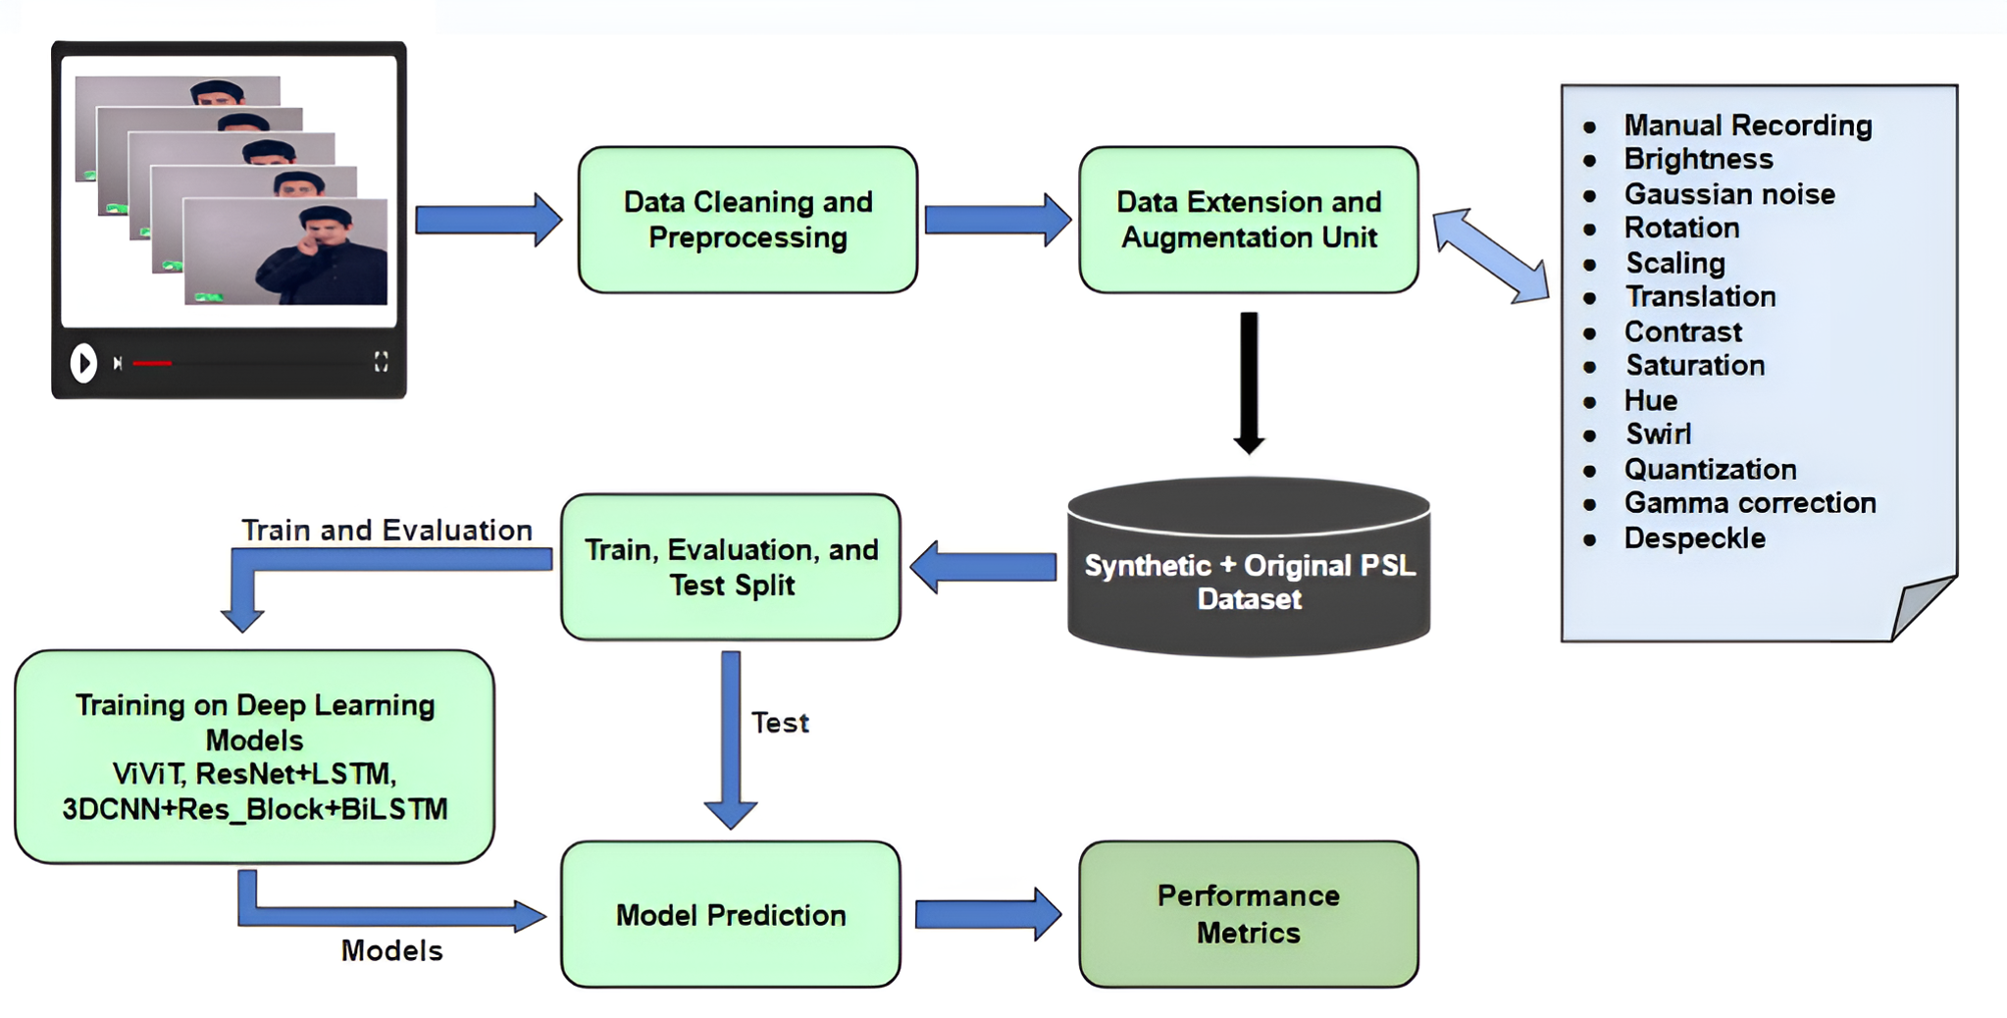

3.1 Data Collection
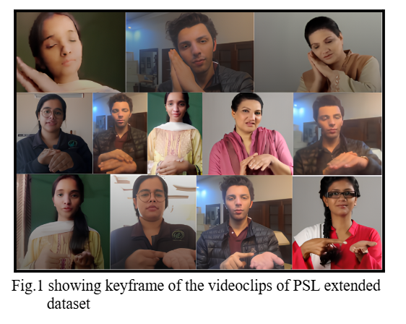
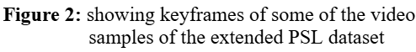
To devise a comprehensive dataset of Pakistan Sign Language (PSL) including 104 daily-use signs, we collaborated with the PSL Organization [12], to extract the original signs’ videos. For further extending the dataset and resolving the issue of limited PSL dataset w.r.t example videos per each sign, we included three team members’ video clips in the PSL dataset. Initially, each of the 104 sign labels had one official video provided by the PSL organization. Each of the three team members further recorded three videos per label/sign, leading to a total of 10 diverse and original video samples per sign. All the recordings were consistent with the original video in terms of hand movements and expressions. Fig.2 shows the keyframe of the videoclips of the extended PSL dataset.

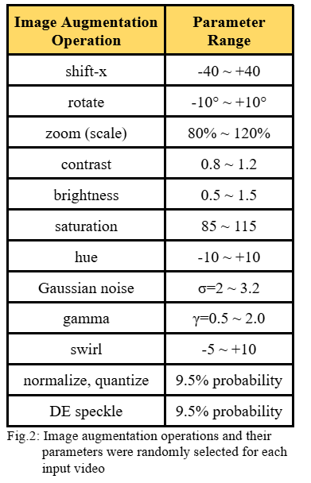
3.2 Data Augmentation and Preparation
The ten video clips per PSL sign was still found to be a very small number for effective training of deep learning models. Therefore, to introduce generalization and tackle overfitting issues, the image augmentation approaches were used. Since our PSL dataset consists of video samples, the videos were augmented by applying augmentation techniques on all frames of video clips by one at a time. The eleven different augmentations were applied as inspired by [13][1]. Table 1 lists down the image augmentation operations with its parameters chosen and configured with randomness for data augmentation.
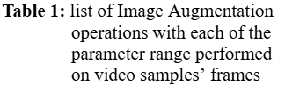
With the varying image augmentation operations’ parameters ranges, each sign’s videos were randomly shuffled and then selected randomly on which any of the randomly selected augmentation was applied.
This yielded a final dataset of 60 videos per sign from 10 videos per sign. Each video was further standardized to pixel values scaled to [0,1].
It is worth mentioning that the augmentation was applied on the whole PSL dataset, and then the splits on the dataset for training, evaluation, and test dataset were performed.

3.3 Training, Evaluation, and Test Split
Once the final PSL dataset was available, the train, evaluation, and test dataset was split to ensure that deep learning models’ training was effective. Since each PSL sign has 60 videos, 80% of videos were moved to training set, 15% of videos were moved to evaluation set, and remaining 5% of videos into test set. This step was repeated for each PSL sign/label.
Finally, we had a total of 4992 training examples, 832 validation examples, and 416 test examples.

3.4 Training of Deep Learning Models
Utilizing both Machine Learning (ML) and deep learning (DL) approaches, we evaluated three different advanced deep learning models to determine the most effective model for the PSL recognition system.

3.4.1 Video Vision Transformer (ViViT) Model
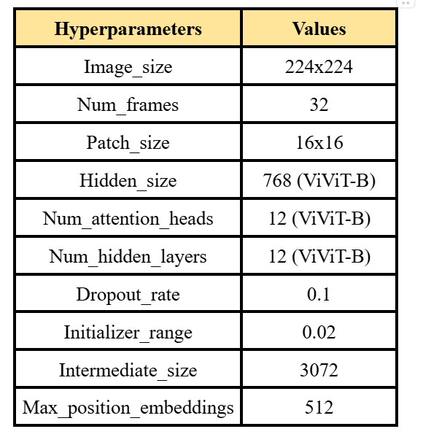
ViViT/32 [14] extends the Vision Transformer (ViT) model by adding temporal modeling across video frames. This model uses tubelets, which are small spatiotemporal regions of interest in a video, and process them using self-attention mechanisms. The ViViT with tubelet embeddings was found to be able to better capture spatio-temporal relations between different regions of video sample, which helps to improve performance on video recognition tasks [14]. We trained the ViViT model on our final PSL dataset, where each input video was split into 32 frames, and each frame was divided into 16x16 patches.
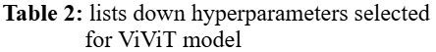
A spatio-temporal embedding strategy was used, which combined 2D spatial and 1D temporal positional encodings. The embedded patches were further passed through 12 transformer layers, each with multi-head attention. A classification token “[CLS]” aggregated information across space and time was used for final prediction. Table 2 shows the hyperparameters tuned for the ViViT model for training. Despite strong training performance with accuracy around 96%, the ViViT model exhibited overfitting with large performance drop between training and evaluation datasets, likely due to model size and limited dataset for proper generalization across PSL signs.

3.4.2 ResNet-18 and LSTM network
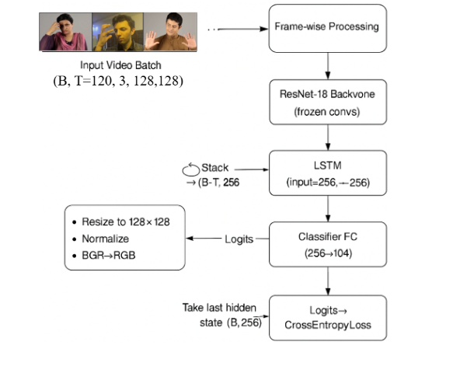
The ResNet-18 model, pre-trained on ImageNet-1K [15] dataset with LSTM architecture was next trained on PSL final dataset. This network, as proposed by [16], was known for its ability to generalize well, less compute requirements as a pretrained model was incorporated, and can extract spatial features well via a pre trained backbone while modeling temporal dynamics. Each input video of 120RGB frames was extracted only. If input video has less than 120 frames the padding with black frames (zeros) to reach exactly desired frames. These frames were then resized to 128x128 pixels and passed through frozen ResNet-18 architecture. The final fully connected layer of the ResNet-18 network was trainable only. The extracted spatial features of each frame were then in turn fed into a one-layer LSTM, followed by a linear classification layer. The GPU used for training was Nvidia GTX 1660 Ti.
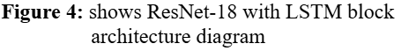
The training was done for 70 epochs with a batch size of 8. The initial learning rate was selected to be 1e-4 with weight decay of 5x10-4. The optimizer chosen was Adam. The Learning Scheduler technique was “ReduceLROnPlateau” with factor=0.1, patience=5, and threshold=1e-4. The loss used was “CrossEntropyLoss” with label_smoothing=0.1. Fig. 4 shows the ResNet-18 and LSTM architecture.
Though training metrics were high, the model underperformed on evaluation set, indicating that overfitting was a slight issue in the ResNet-18 and LSTM network.

3.4.3 3DCNN + Residual Block + BiLSTM
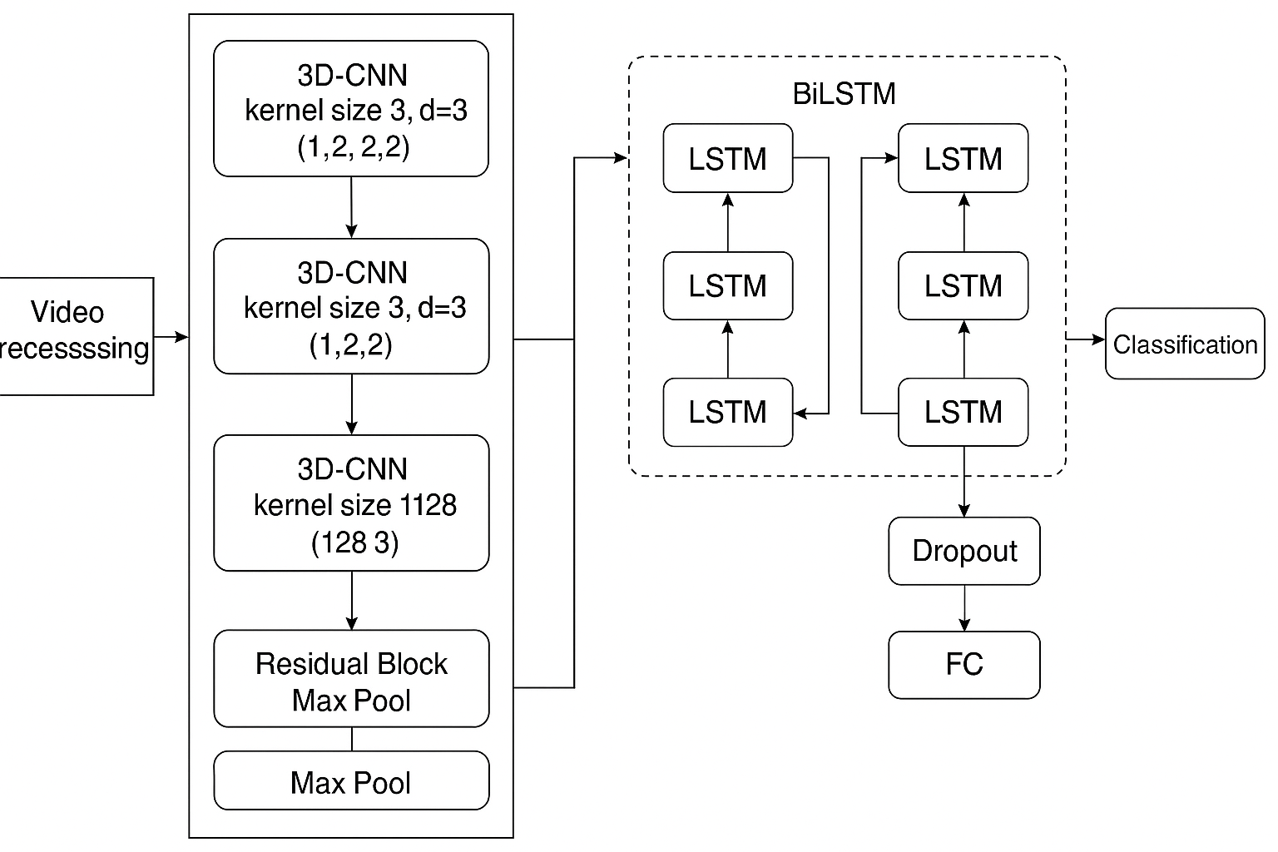
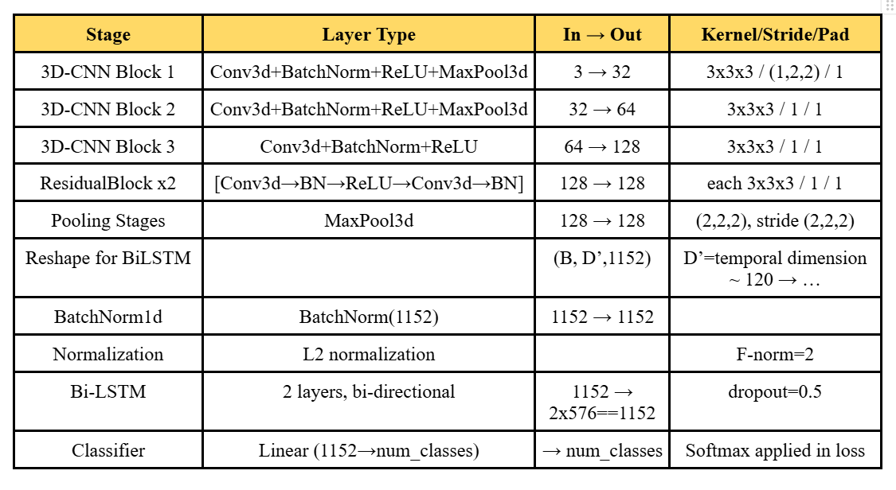
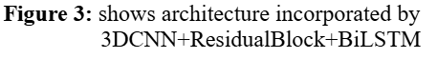
To better capture spatiotemporal dependencies and incorporate the robust network for PSL recognition system, we designed a hybrid model combining 3D convolution, residual learning, and bidirectional LSTMs, as inspired by networks proposed by [17] and [18]. The proposed Deep Convolutional-3D BiLSTM Multi-head Attention network by [7] was found to be effective in recognizing Americation Wh-Question word sign gestures, which was found to map effectively to our problem statement. This network helped to verify the effectiveness of the BiLSTM with C3D to analyze temporal dependencies better within each feature map.
The Residual 3D Convolutional Neural Network (DA-R3DCNN) [18] model also helped to determine the addition of Residual Block within 3DCNN can help to produce better recognition results.
Therefore, using both approaches [17] [18], we propose the robust and reliable network “3DCNN + Residual Block + BiLSTM”. The architecture, as shown in Fig. 3, was trained from scratch and significantly improved performance.
The initial 3D convolution blocks were followed by BachNorm3d layers to introduce faster convergence and stable gradients. Two stacked residual blocks allowed deeper learning by enabling smooth gradient flow and overcoming gradient issues. Max pooling layers were interleaved after residual blocks, to reduce spatial dimensions and improve feature granularity. A two-layered biLSTM helped to capture long-range temporal dependencies in both forward and backward directions. Lastly, L2 regularization helped to tackle the overfitting issue across 104-class output space. Table. 3 details the layer details of 3DCNN + Residual Block + BiLSTM architecture.
The total of 9.3 million trainable parameters, and hyperparameters tuning as follows:
- Batch Size: 8
- Epochs: 10
- Optimizer: Adam
- Weight Decay: 1e-4
- Initial Learning rate: 1e-3
- Scheduler: ReduceLROnPlateau with patience=5 and monitor=validation loss.
- Loss: CrossEntropyLoss
This network was found to achieve better generalization across each of the dataset.

4. RESULTS

4.1 Evaluation Metrics
The most significant performance metrics were selected as per the classification task. Since our final PSL dataset is very evenly balanced with respect to video samples per PSL sign, accuracy is the appropriate measure to evaluate. Accuracy is the percentage of correctly predicted video samples from all samples in PSL dataset as given by E.q.1. Metrics such as recall, precision, and F1 score are also used for evaluation purposes. A prediction is considered correct if the top-1 prediction, i.e., suggestion with highest probability matches the PSL sign in actual. Usually, for a two-class dataset where one class is assumed positive while other negative, we used equations for multi-class dataset [1] where precision, recall, and F1 score are calculated for each class as Eqs 2,3,4.

$Accuracy = Correct Predictions÷Total Number of Samples$ (1)

$Recall = \frac{TP or correct predictions of 'c'}{Predictions labeled as 'c'}$ (2)

$Precision = \frac{TP or correct predictions of 'c'}{Num of actual 'c' samples}$ (3)

$F1 score = \frac{2 x precision x recall}{precision + recall}$ (4)

4.2 Results Analysis
Table 4 compares the results of performance metrics produced by each of the deep learning models.
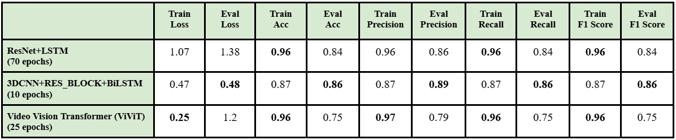
This suggests that even though the ViViT model was effective for the training set, a huge performance drop was found in evaluation set’s metrics, which suggests the overfitting issue in the ViViT model. The same issue was found with the ResNet and LSTM network, however the difference between evaluation and training was less comparatively to the ViViT model, while maintaining around similar performance metrics as the ViViT model. Lastly, our proposed model was found to generalize better out of all, while maintaining the minimal difference between the training and evaluation performance metrics.
Fig. 5 shows the graph plots showing each of the performance metrics history for 3DCNN + ResidualBlock + BiLSTM.
Further, for the test dataset (unseen video samples) 83.89% accuracy was reported for 3DCNN + ResidualBlock + BiLSTM with loss of 0.59, precision=0.88, recall=0.84, and F1 score=0.84. This further proves the effectiveness of the network.
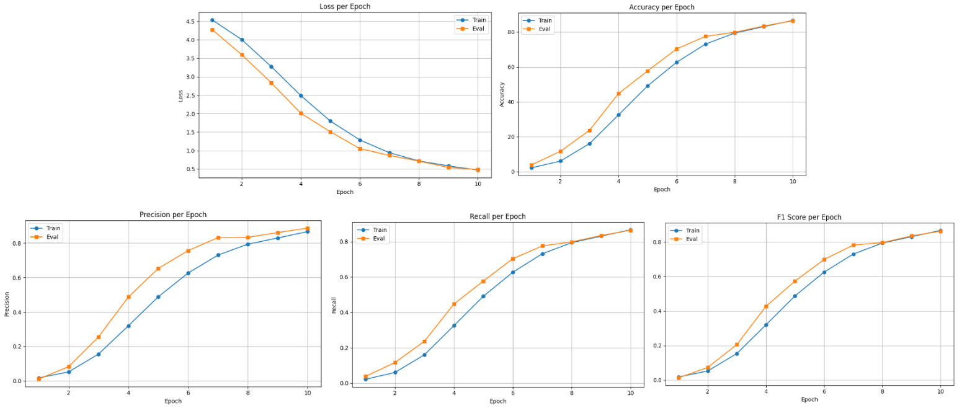

5. CONCLUSION
This work presents a comprehensive PSL (Pakistani Sign Language) recognition system that addresses the communication gap faced by the deaf community in Pakistan. By assembling a diversified dataset of 104 daily-use PSL signs and applying extensive frame-level augmentations, we significantly enhanced the volume and variability of training data. Among the three evaluated models, our proposed hybrid architecture combining 3DCNN, Residual Blocks, and BiLSTM achieved the best generalization performance with an accuracy of 83.89% and an F1 score of 0.84 on unseen data. These results highlight the potential of deep learning in enabling real-time PSL translation, contributing toward more inclusive communication technologies for the deaf community.

REFERENCES
- Hamza, H.M., Wali, A. Pakistan sign language recognition: leveraging deep learning models with limited dataset. Machine Vision and Applications 34, 71 (2023). https://doi.org/10.1007/s00138-023-01429-8
- World Health Organization (WHO). “Deafness and hearing loss.” World Health Organization (WHO), 2 February 2024, https://www.who.int/news-room/fact-sheets/detail/deafness-and-hearing-loss. Accessed 16 September 2024.
- Dhanjee, Azima. “Sign Language Accessibility for the Deaf in Pakistan.” YES Programs, 11 October 2018,
https://www.yesprograms.org/stories/sign-language-accessibility-for-the-deaf-in-pakistan. Accessed 16 September 2024.
- Abbas, Ali & Sarfraz, Summaira & Tariq, Umbreen. (2022). Pakistan sign language translation tool in educational setting: teachers perspective. 16. 38-47. 10.1108/JET-06-2021-0033.
- Khan, N. S., Abid, A., Abid, K., Farooq, U., Farooq, M. S., & Jameel, H. (2015). Speak Pakistan: Challenges in Developing Pakistan Sign Language using Information Technology. South Asian Studies, 30(2), 367.
- Garcia, B., & Viesca, S. (2016). Real-time American Sign Language recognition with convolutional neural networks. Convolutional Neural Networks for Visual Recognition.
- Pigou, L., Van Den Oord, A., Dieleman, S., Van Herreweghe, M., & Dambre, J. (2018). Beyond temporal pooling: Recurrence and temporal convolutions for gesture recognition in video. International Journal of Computer Vision, 126(2-4), 430-439.
- A. Imran, A. Razzaq, I. A. Baig, A. Hussain, S. Shahid et al., “Dataset of Pakistan sign language and automatic recognition of hand configuration of urdu alphabet through machine learning,” Data in Brief, vol. 36, pp. 107021, 2021.
- Smirnova, S., & Kuznietsova, N. (Year). Application of vision transformers and 3D convolutional neural networks for sign language cluster recognition. https://ceur-ws.org/Vol-3392/paper13.pdf
- Huang, J., & Chouvatut, V. (2024). Video-Based Sign Language Recognition via ResNet and LSTM Network. Journal of Imaging, 10(6), 149. https://doi.org/10.3390/jimaging10060149
- Arnab Dey, Samit Biswas, Dac-Nhuong Le, Recognition of Wh-Question Sign Gestures in Video Streams using an Attention Driven C3D-BiLSTM Network, Procedia Computer Science, Volume 235, 2024,Pages 2920-2931,ISSN 1877-0509, https://doi.org/10.1016/j.procs.2024.04.276
- Pakistan Super League. (n.d.). Retrieved May 14, 2025, from https://psl.org.pk/
- Kim, J., & O’Neill-Brown, P. (2019). Improving American Sign Language recognition with synthetic data. In Proceedings of the 17th Machine Translation Summit (MT Summit XVII) (pp. 151–158). Association for Machine Translation in the Americas. https://aclanthology.org/W19-6615.pdf
- Smirnova, S., & Kuznietsova, N. (2023). Application of vision transformers and 3D convolutional neural networks for sign language cluster recognition. In Proceedings of the Sixth International Workshop on Computer Modeling and Intelligent Systems (CMIS-2023) (Vol. 3392, pp. 124–132). CEUR-WS.org. https://ceur-ws.org/Vol-3392/paper13.pdf
- J. Deng, W. Dong, R. Socher, L. -J. Li, Kai Li and Li Fei-Fei, "ImageNet: A large-scale hierarchical image database," 2009 IEEE Conference on Computer Vision and Pattern Recognition, Miami, FL, USA, 2009, pp. 248-255, doi: 10.1109/CVPR.2009.5206848. keywords: {Large-scale systems;Image databases;Explosions;Internet;Robustness;Information retrieval;Image retrieval;Multimedia databases;Ontologies;Spine},
- Hossain, M. S., & Muhammad, G. (2024). Video-based sign language recognition via ResNet and LSTM network. Journal of Imaging, 10(6), 149. https://www.mdpi.com/2313-433X/10/6/149
- Zhang, Y., Li, X., & Wang, L. (2024). A comprehensive survey on deep learning-based sign language recognition. Procedia Computer Science, 223, 123–130. https://www.sciencedirect.com/science/article/pii/S1877050924009554
- Chen, Y., Liu, H., & Zhao, Q. (2023). Human action representation learning using an attention-driven residual 3DCNN network. Algorithms, 16(8), 369. https://www.mdpi.com/1999-4893/16/8/369

